**THE DATASET**

The advertising dataset provides insights into the relationship between advertising expenditures and sales revenue through various media channels, including radio, television (TV), and newspapers. This dataset comprises 200 data points (rows) and features 4 informative columns: 'Newspaper,' 'Radio,' 'TV,' and 'Sales.' It offers a comprehensive view of the impact of advertising investments on sales performance. Below is the first 4 rows of the dataset (the 4 rows is picked from 0-3)

|  |  |  |  |
| --- | --- | --- | --- |
| **TV** | **Radio** | **Newspaper** | **Sales** |
| 230.1 | 37.8 | 69.2 | 22.1 |
| 44.5 | 39.3 | 45.1 | 10.4 |
| 17.2 | 45.9 | 69.3 | 12.0 |
| 151.5 | 41.3 | 58.5 | 16.5 |

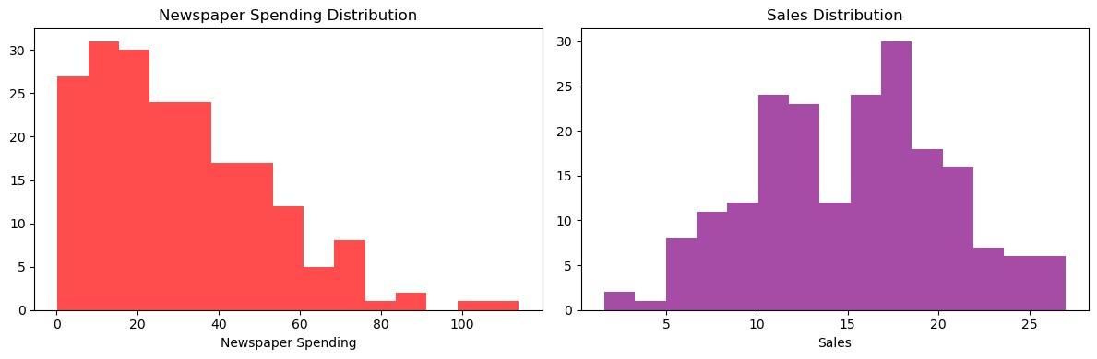

The chart above provides a visualization of the distribution of advertising expenditure in the newspaper channel alongside its corresponding impact on sales. Notably, the distribution of newspaper expenditure exhibits a right-skew pattern, indicating that as we progress from lower to higher levels of expenditure, the rate of spending on newspaper advertising tends to decrease. This information sheds light on the relationship between newspaper ad spending and its influence on sales. These statistics collectively suggest that the distribution of sales is approximately normally distributed (zero skew), with a slight rightward skew. While the majority of sales fall within the interquartile range (IQR) of 11 to 19.05, the presence of outliers on the higher end may contribute to the mild skew in the distribution. Overall, the data indicates a central tendency around 15.13 with a moderate degree of variability, making it somewhat normally distributed with a slight positive skew.

*NOTE! “Right-skewed distributions indicate that the majority of the data is located on the left side of the graph, and the mean, or average, is greater than the median. There are values in the data set that are much greater than the median, or the value where 50% of the data is either lower or higher. In symmetric distributions, we expect the mean and median to be approximately equal in value. This is an important connection between the shape of the distribution and the relationship of the mean and median”*

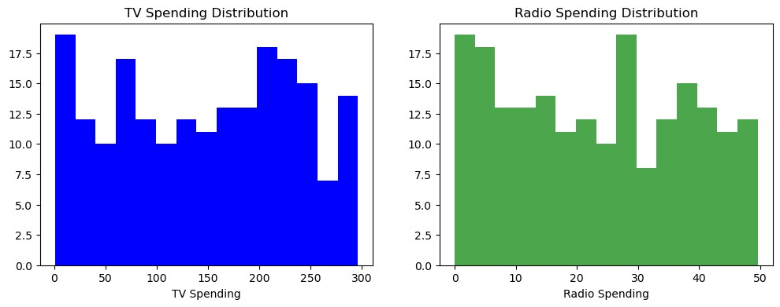

The chart above provides a visual depiction of the distribution of advertising expenditures, differentiating between **TV and radio spending**. Notable patterns emerge within each medium:

**For TV Spending**: The chart illustrates that the highest concentration of TV spending falls within the range of 0 to 20units. This indicates that a significant portion of the data points allocates budget in this higher spending bracket. Conversely, the lowest TV spending is observed in the vicinity of 250 to 270 units.

**For** **Radio Spending**: The chart reveals a distinctive pattern for radio spending. There are noticeable peaks in the expenditure data, primarily in two ranges: 0 to 5 units and 25 to 30 units. This suggests that there is a considerable increase in spending within these ranges, which may signify preferred budget allocations. In contrast, the lowest radio spending occurs between 30 and 35 units.

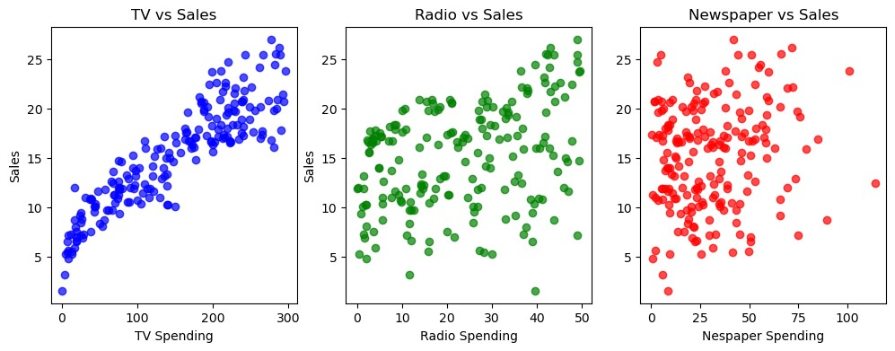

The scatter plots displayed above depict the relationships between advertising expenditures on **TV, Radio, and Newspaper** and their respective impacts on sales. Notably, these plots provide insights into the degree of linear association between each advertising channel and sales performance. In the case of TV advertising spending, it is evident that there is a relatively stronger linear relationship with sales. This observation is supported by the visual trend where an increase in TV spending corresponds to a more noticeable and consistent increase in sales. In other words, higher TV advertising budgets tend to result in higher sales figures, indicating a positive linear correlation In contrast, Radio and Newspaper spending show weaker and less consistent linear relationships with sales, indicating their impact varies.

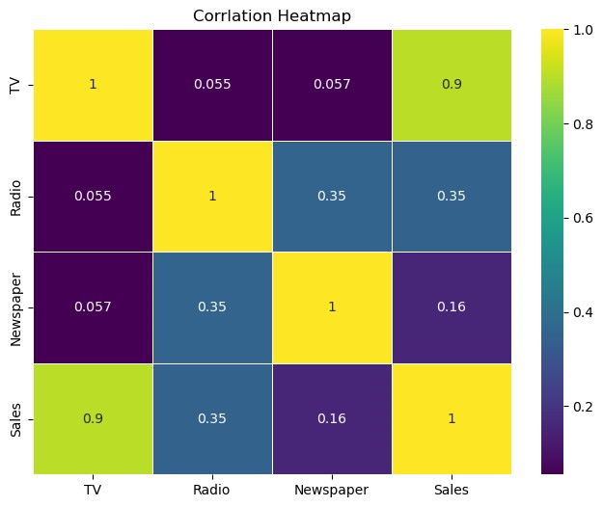

The above chat shows correlations between different variables (TV, Radio, Newspaper, and Sales). TV and Sales have a strong positive correlation of approximately 0.901. This indicates that as the TV advertising budget increases, sales also tend to increase significantly. Radio and Sales have a moderate positive correlation of around 0.350, suggesting that there is a moderate positive relationship between radio advertising spending and sales. An increase in radio advertising is associated with a moderate increase in sales. Newspaper and Sales have a weaker positive correlation of about 0.158. This indicates a weaker relationship between newspaper advertising spending and sales. An increase in newspaper advertising spending is associated with a relatively smaller increase in sales. TV and Radio have a very weak positive correlation of approximately 0.055, suggesting a minimal relationship between TV and radio advertising budgets. TV and Newspaper also exhibit a very weak positive correlation of around 0.057, indicating a minimal relationship between TV and newspaper advertising budgets. Radio and Newspaper have a moderate positive correlation of about 0.354, indicating that there is a moderate positive relationship between radio and newspaper advertising budgets.

**SUMMARY**

In conclusion, this dataset provides valuable insights into the impact of advertising expenditures on sales across different media channels. TV advertising shows the strongest correlation with sales, followed by radio, while newspaper advertising has the weakest correlation. These findings can guide advertising strategies and budget allocation for optimal sales performance.